# Using DDR3 DRAM with MicroBlaze

## Hardware Part

In “Board” tab showing in the figure below, important peripherals on the VC707 evaluation board are showing. It is possible to select the peripheral and add it to the design by just double clicking on it.

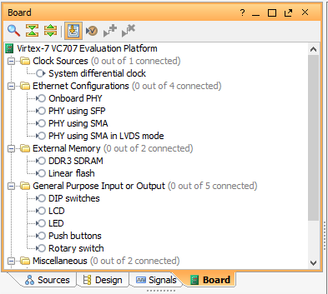

* To add DDR3 SDRAM double click on it. Then click OK on the opening window. That wizard will create a Memory Interface Generator (MIG) to control DRAM. If instead of board, the FPGA chip is selected when opening the project then MIG configurations must be done manually.
* Do not click “Run Connection Automation” in this step.
* Add a MicroBlaze and click on “Run Block Automation”.
* Set the desired configurations except “Clock Connection”. Use “/mig_7series/ui_addn_clk_0” or “/mig_7series/ui_clk” as a clock source. MIG can be configured to generate more than one clock signal with desired frequency. “ui_addn_clk_x” pins will pop up when a new clock output is added. These clocks can be selected.
* Click OK. Add desired peripherals, and click on “Run Connection Automation”.
* Generate Bitstream, export hardware, and open SDK to write C codes.

## Software Part

Following code show how to write one byte value to memory and read it.

|  |
| --- |
| **int**\* DRAM_MEMORY = (**int** *)0x80000000;  **int** **main**(){    **char** dataVar;  // write data to memory  DRAM_MEMORY[1] = 'A';  //read data from memory  dataVar = DRAM_MEMORY[1];    **return** 0;  } |